**ROMANIA DIAGNOSTIC IMAGING DEVICES MARKET**

According to Intelli, the Romania diagnostic imaging devices market was valued at USD 2241 million in 2024 and is projected to reach USD 3128.60 million by 2032, growing at a CAGR of 5.16 % from 2024 to 2032.

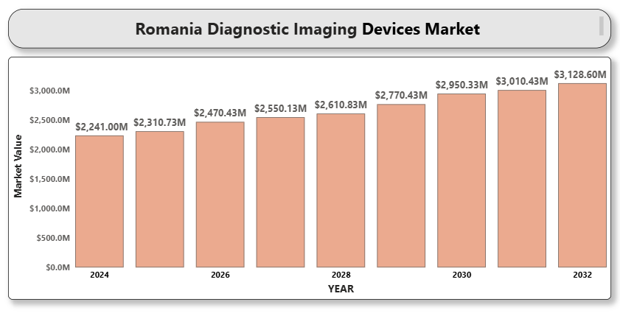  
Romania’s diagnostic imaging devices market is witnessing significant growth, driven by the rising prevalence of chronic diseases, such as cancer and cardiovascular conditions, as well as advancements in imaging technologies. The country benefits from government healthcare initiatives, improving healthcare infrastructure, and increasing investment in diagnostic imaging equipment. Additionally, technological innovations, such as AI-assisted imaging, portable devices, and high-resolution systems, are contributing to the rapid expansion of the market.

**Romania Diagnostic Imaging Devices Market Definition**

Diagnostic imaging devices are used to visualize the internal structures of the body to aid in diagnosing and monitoring diseases. These devices include technologies such as X-ray, MRI, CT scanners, ultrasound, nuclear medicine, and PET scanners. They are vital in a variety of clinical areas, including oncology, cardiology, orthopedics, and neurology. These devices are primarily used in hospitals, outpatient clinics, and specialized diagnostic centers for early disease detection, treatment planning, and monitoring. Innovations in imaging technology, such as improved resolution, portability, and non-invasive procedures, are shaping the future of the diagnostic imaging landscape.

**Romania Diagnostic Imaging Devices Market Overview**

The diagnostic imaging devices market in Romania is defined by growing demand for advanced imaging systems, government-supported healthcare initiatives, and an aging population requiring more diagnostic interventions. Romania's healthcare system continues to modernize, with significant efforts being made to improve access to quality diagnostic services. The market is supported by investments from both the private sector and the European Union (EU) to modernize healthcare infrastructure and increase the availability of high-tech diagnostic equipment. However, challenges such as high device costs and the need for skilled personnel may slow down widespread adoption in certain regions. Nevertheless, the Romanian market is expected to witness strong growth due to rising healthcare expenditure, technological advancements, and improving diagnostic capabilities.

**Romania Diagnostic Imaging Devices Market Segmentation Analysis**

**Market Segmentation by Product Type:**

* **X-ray Systems**
* **MRI Systems**
* **CT Scanners**
* **Ultrasound Systems**
* **Nuclear Imaging Systems (PET, SPECT)**
* **Mammography Systems**
* **Visualization Systems (e.g., monitors and software)**
* **Imaging Accessories (e.g., contrast media, imaging plates)**

X-ray systems hold the largest share of the Romanian diagnostic imaging devices market, followed by MRI and CT scanners, which are seeing increasing adoption due to their role in accurate disease diagnosis, especially in oncology and cardiology. Ultrasound systems are also growing, particularly in obstetrics and musculoskeletal diagnostics. Nuclear imaging systems (PET/SPECT) are expected to gain traction, especially in oncology.

**Market Segmentation by Application:**

* **Oncology Imaging**
* **Cardiology Imaging**
* **Orthopedic Imaging**
* **Neurological Imaging**
* **Gynecological Imaging**
* **Pediatric Imaging**
* **Other Applications (e.g., trauma, infections)**

Oncology imaging holds the largest market share due to the growing incidence of cancer, with increasing demand for PET and CT scans for cancer detection and monitoring. Cardiology imaging is also expanding due to rising cardiovascular diseases. Orthopedic imaging, particularly for joint and bone disorders, follows closely.

**Market Segmentation by End User:**

* **Hospitals**
* **Ambulatory Surgical Centers**
* **Specialty Clinics**
* **Academic & Research Institutions**

Hospitals are the primary consumers of diagnostic imaging devices due to their need for a broad range of imaging technologies for diagnosis and treatment. Ambulatory surgical centers are also growing, driven by the increasing demand for outpatient diagnostic services.

**Market Segmentation by Region:**

* **Bucharest**
* **Cluj-Napoca**
* **Timisoara**
* **Iasi**
* **Other Regions (e.g., Constanta, Brasov)**

Bucharest is the leading region in the diagnostic imaging devices market, due to its well-developed healthcare infrastructure and high patient volume. Other regions such as Cluj-Napoca, Timisoara, and Iasi are seeing significant growth, as investments in healthcare are expanding beyond the capital.

**Key Players**

The Romania diagnostic imaging devices market is served by global leaders and regional manufacturers. Key players include:

* **GE Healthcare**
* **Siemens Healthineers**
* **Philips Healthcare**
* **Canon Medical Systems**
* **Hitachi Medical Systems**
* **Samsung Medison**
* **Fujifilm Holdings Corporation**
* **Toshiba Medical Systems**
* **Medtronic plc**

These companies compete on the basis of product innovation, imaging quality, price, and after-sales services. GE Healthcare and Siemens Healthineers are dominant players in the market, leading in advanced imaging solutions such as MRI and CT scanners.

**Key Developments**

* **March 2024**: GE Healthcare introduced the new Revolution Apex CT scanner, featuring advanced imaging capabilities for early disease detection.
* **May 2023**: Siemens Healthineers launched its latest AI-driven MRI system, enhancing image clarity and diagnostic accuracy.

Romania is an attractive market for diagnostic imaging devices due to the country's increasing healthcare expenditure, growing demand for early and accurate disease diagnosis, and government-backed initiatives to modernize healthcare facilities. With a rising burden of chronic diseases and an aging population, the market presents significant growth opportunities for both established and emerging players. Furthermore, the push toward non-invasive and portable diagnostic technologies is expected to drive further adoption in both hospital and outpatient settings.

**Porter’s Five Forces**

* **A close-up of hands holding a tablet and a pen

  Description automatically generatedThreat of New Entrants**: Moderate. Regulatory barriers and the need for high capital investment may limit entry, but niche players offering AI-powered imaging solutions could find entry points.
* **Bargaining Power of Suppliers**: Moderate. While suppliers of critical components for imaging systems have some leverage, there is a broad range of suppliers.
* **Bargaining Power of Buyers**: High. The public healthcare sector in Romania is a major buyer and has significant negotiating power, demanding cost-effective solutions.
* **Threat of Substitutes**: Low. Diagnostic imaging remains unique in providing detailed, non-invasive visualization of the body’s internal structures.
* **Industry Rivalry**: High. The market is highly competitive with multiple players vying for market share by offering innovative solutions, improving image quality, and providing comprehensive service agreements.

**TABLE OF CONTENTS**

1. **INTRODUCTION OF ROMANIA DIAGNOSTIC IMAGING DEVICES MARKET**

1.1 Overview of the Market  
1.2 Scope of Report  
1.3 Assumptions

1. **EXECUTIVE SUMMARY**
2. **RESEARCH METHODOLOGY**  
   3.1 Data Mining  
   3.2 Validation  
   3.3 Primary Interviews  
   3.4 List of Data Sources
3. **ROMANIA DIAGNOSTIC IMAGING DEVICES MARKET OUTLOOK**  
   4.1 Overview  
   4.2 Market Dynamics  
   4.2.1 Drivers  
   4.2.2 Restraints  
   4.2.3 Opportunities  
   4.2.4 Trends  
   4.3 Porter’s Five Force Model  
   4.4 Value Chain Analysis
4. **ROMANIA DIAGNOSTIC IMAGING DEVICES MARKET, BY PRODUCT TYPE**  
   5.1 X-ray Systems  
   5.2 MRI Systems  
   5.3 CT Scanners  
   5.4 Ultrasound Systems  
   5.5 Nuclear Imaging Systems  
   5.6 Mammography Systems  
   5.7 Visualization Systems  
   5.8 Imaging Accessories
5. **A close-up of hands holding a tablet and a pen

   Description automatically generatedROMANIA DIAGNOSTIC IMAGING DEVICES MARKET, BY APPLICATION**  
   6.1 Oncology Imaging  
   6.2 Cardiology Imaging  
   6.3 Orthopedic Imaging  
   6.4 Neurological Imaging  
   6.5 Gynecological Imaging  
   6.6 Pediatric Imaging  
   6.7 Other Applications
6. **ROMANIA DIAGNOSTIC IMAGING DEVICES MARKET, BY END USER**  
   7.1 Hospitals  
   7.2 Ambulatory Surgical Centers  
   7.3 Specialty Clinics  
   7.4 Academic & Research Institutions
7. **ROMANIA DIAGNOSTIC IMAGING DEVICES MARKET, BY REGION**  
   8.1 Bucharest  
   8.2 Cluj-Napoca  
   8.3 Timisoara  
   8.4 Iasi  
   8.5 Other Regions
8. **ROMANIA DIAGNOSTIC IMAGING DEVICES MARKET COMPETITIVE LANDSCAPE**  
   9.1 Overview  
   9.2 Company Market Ranking  
   9.3 Key Development Strategies
9. **COMPANY PROFILES**  
   **10.1 GE Healthcare**10.1.1 Overview  
   10.1.2 Financial Performance  
   10.1.3 Product Outlook  
   10.1.4 Key Developments  
   **10.2 Siemens Healthineers**10.2.1 Overview  
   10.2.2 Financial Performance  
   10.2.3 Product Outlook  
   10.2.4 Key Developments  
   **10.3 Philips Healthcare**10.3.1 Overview  
   10.3.2 Financial Performance  
   10.3.3 Product Outlook  
   10.3.4 Key Developments  
   **10.4 Canon Medical Systems**10.4.1 Overview  
   10.4.2 Financial Performance  
   10.4.3 Product Outlook  
   10.4.4 Key Developments  
   **10.5 Hitachi Medical Systems**10.5.1 Overview  
   10.5.2 Financial Performance  
   10.5.3 Product Outlook  
   10.5.4 Key Developments
10. **A close-up of hands holding a tablet and a pen

    Description automatically generatedKEY DEVELOPMENTS**  
    11.1 Product Launches/Developments  
    11.2 Mergers and Acquisitions  
    11.3 Business Expansions  
    11.4 Partnerships and Collaborations
11. **APPENDIX**  
    12.1 Related Research